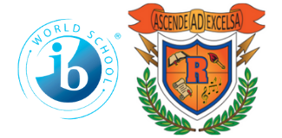
Ridgeway International Baccalaureate
Middle World Optional School
2022-2023
7th GRADE School Supply List

Parents/Guardians:

We appreciate you helping us to get the school year off to a great start by helping us with the supplies requested on this supply list. We look forward to meeting you and your child. If you have any questions, please feel free to contact any 7th grade teacher.

- Markers
- Colored Pencils
- Mechanical Pencils/Wood Pencils
- Pencil Pouch
- Crayons
- Notebook Paper
- Graphing Paper with holes
- Hand Pencil Sharpener with Cover
- 2 Packs of #2 Pencils
- Pens- Red, Blue, and Black (2 Packs of Each)
- Highlighters
- Scientific Calculator
- Glue Sticks
- USB DRIVE
- Dry Erase Markers
- 6 - 100 sheet Composition Books (Math)
- 6 – 2 Pocket Folders (Math)
- Earphones (All subjects)
- 4 – 2 Pocket Folders
- Clorox Wipes
- 2 Boxes of Kleenex
- Hand Sanitizer
- 5 – 1” 3 Ring Binders (1 for Science)
- 1 – 2” 3 Ring Binder (Math Only)
- $5.00 Science Fee

**Exploratory Classes (Art, Vocal Music, Band, STEM, Strings) will need other supplies which will be communicated when students attend assigned classes!!**

